Screen Control and Sound

Position of text
Screen Control
uses crt;
Control the screen display and output special effects on the screen.
clrscr;
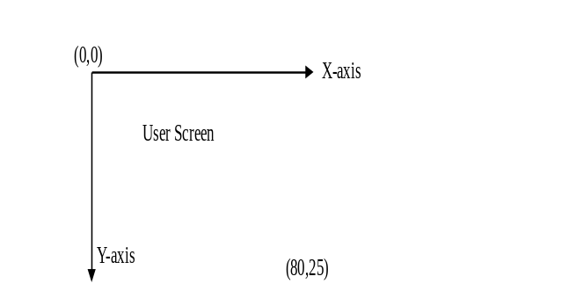
Clear the screen and return the cursor to the 1st column and 1st row on the screen.
gotoxy(x, y);
Move the cursor to the x^{th} column and y^{th} row on the screen.

Example
program Positiontext;
uses crt;
begin
clrscr;
gotoxy(1, 2);
writeln(‘I am here’);
gotoxy(3, 3);
writeln(‘I go there’);
gotoxy(7, 5);
writeln(‘I stop here’)
end.
The above program will produce the following output on the screen.
I |  | a | m |  | h | e | r | e
 |  | I |  | g | o |  | t | h | e | r | e
 |  |  |  |  |  | I |  | s | t | o | p |  | h | e | r | e

Foreground and Background Colours
Set background colour
textbackground(n)
Change the colour of the output window (background colour) to colour index n. A table for the background colour index is shown as follows:
Background colour | Index
Black | 0
Blue | 1
Green | 2
Cyan | 3
Red | 4
Magenta | 5
Brown | 6
Lightgray | 7
Set foreground colour:
textcolor(n)
Change the colour of the text output (foreground colour) to colour index n. A table for the foreground colour index is shown as follows:

Foreground colour | Index | Foreground colour | Index
Black | 0 | Darkgray | 8
Blue | 1 | Lightblue | 9
Green | 2 | Lightgreen | 10
Cyan | 3 | Lightcyan | 11
Red | 4 | Lightred | 12
Magenta | 5 | Lightmagenta | 13
Brown | 6 | Yellow | 14
Lightgray | 7 | White | 15

Example
program colour;
uses crt;
begin
textbackground(0); {Set background colour to black}
textcolor(2); {Set text colour to green}
writeln(‘Green text’);
textbackground(4); {Set background colour to red}
textcolor(0); {Set text colour to black}
writeln(‘Red background’)
end.

Sound Effect
Generate sound:
sound(f)
Generate sound of frequency f with the internal speaker.
Notes | Frequency | Notes | Frequency
C | 131 | B | 494
D | 147 | C | 523
E | 165 | D | 587
F | 175 | E | 659
G | 196 | F | 698
A | 220 | G | 784
B | 247 | A | 880
C | 262 | B | 988
D | 294 | C | 1047
E | 330 | D | 1175
F | 349 | E | 1319
G | 392 | F | 1397
A | 440 | G | 1568
delay(s)
Delay execution of the next statement in the program by s milliseconds.
Stop the generation of sound:
nosound
Stop the internal speaker from generating sound.

Example:
program Dog_bark;
uses crt;
var name : string;
begin
write(‘How do you call your dog? ’);
readln(name);
writeln;
writeln(‘Stop here, ‘, name);
writeln(name, ‘ barks!’);
writeln(‘Woo!’);
sound(180);
delay(300);
writeln(‘Woo!’);
sound(180);
delay(300);
nosound
end.

Computer Graphics
We use Pascal to draw graph in order to make programming more interesting and easier to understand.

Coordinate
Computer graph consists of many points. We can use coordinate to represent points in user screen. For example, (0,0) is the left top corner of the screen, (639, 479) is the right bottom corner of the screen
(Fig. 1) User screen have 640 × 480 points.
(639,479)
x-axis
y-axis
(0,0)
User Screen

Fig. 1 : Coordinate of User screen
Now, we can try a Pascal program. Record the result.
program graphics;
uses graph;
var d, m : integer;
begin
d := detect;
initgraph(d, m, ‘’);
line(20,50,20,250); { vertical line }
line(50,100,350,100); { horizontal line }
line(50,50,350,250)
end.
Computer Graphics (rectangle, ellipse, colour)
Try the following program:
program Drawing;
uses graph;
var d, m : integer;
begin
d := detect;
initgraph(d, m, '');
ellipse(100,30,0,360,10,30);
setcolor(yellow);
rectangle(100,200,300,400);
setcolor(red);
bar(10,20,100,200)
end.

Remark :
Ellipse(100,30,0,360,10,30) draw a ellipse, centre at (100,30), from 0° to 360°, horizontal axis equals to 10, vertical axis equals to 30.
Vertical axis

Horizontal axis

Rectangle(100,200,300,400) draw a rectangle, left top corner at (100,200), right bottom corner (300,400).
Bar is similar to rectangle. It gives a solid rectangle.
setcolor(colour/value) set colour as shown in following table:

Integer value | Symbol (colour) | Colour
0 | Black | Black
1 | Blue | Blue
2 | Green | Green
3 | Cyan | Cyan
4 | Red | Red
5 | Magenta | Magenta
6 | Brown | Brown
7 | Lightgray | Lightgray
8 | Darkgray | Darkgray
9 | Lightblue | Lightblue
10 | Lightgreen | Lightgreen
11 | Lightcyan | Lightcyan
12 | Lightred | Lightred
13 | Lightmagenta | Lightmagenta
14 | Yellow | Yellow
15 | White | White

